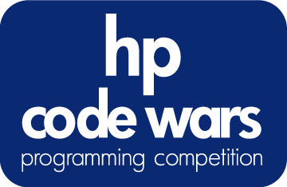

Check Please?
Problem #11 | Advanced | 9 Points

C programmers: your program name must be: prob11.exe
JAVA programmers: your program name must be Prob11.class

Task Description
The menu for the local Lone Star Diner is as follows:

COFFEE – $0.50
SODA - $1.00
MILKSHAKE - $2.13
PANCAKES - $3.25
WAFFLES - $3.92
HAMBURGER – $4.01
PASTA - $4.44
HOTDOG - $2.98
CHIPS - $0.65
FRIES - $0.99

Write a program that takes a given list of menu items that have been ordered and displays the total bill.

Program Input
The customer’s order is contained in an input file (c:\codewars\prob11.in). The input file will contain a list of items ordered by the customer. Each item will be on a separate line. “END” will signify the end of the order.

COFFEE
COFFEE
WAFFLES
PASTA
END

Oh, and by the way, when the diner gets really busy, the waiters get a little sloppy with the order entry so there may be a typo (or not) in each line of the order. A typo will only consist of a single missing letter or having a single wrong letter per each item name, but not both. For example:

CONFEE
OFFEE
WAIFLES
PASTE
END

You can assume END will always be spelled correctly.

Program Output
The total cost of the order, as follows:
Your total is $9.36

